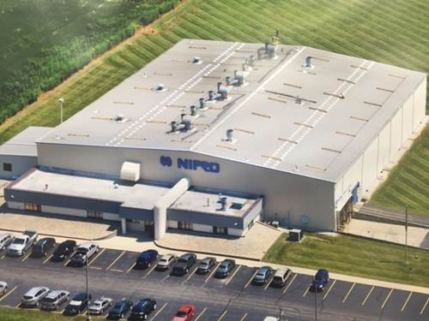

Nipro PharmaPackaging Americas Corporation

Quality Supervisor

Location | Westport IN
Reporting Relationship | Plant Quality Manager
Website | www.nipro-pharmapackaging.com

COMPANY BACKGROUND/CULTURE
Nipro PharmaPackaging has more than 60 years of experience in the fields of drawing premium glass tubing, developing and manufacturing innovative primary packaging, performing distinct pharma packaging analysis and assembling high-performance converting machines.

Our vision is to be the preferred partner of pharmaceutical drug manufacturers by bringing to the world an innovative portfolio of quality products that anticipate upcoming changes and trends in the drug arena.

Our mission, as a preferred partner, is to:
- Advise on and create advanced packaging solutions for early drug developments.
- Improve and enhance packaging solutions for existing drugs.
- Contribute to ensure a safer and healthier experience.

Our values are fueled by innovation and embracing progress and change. Nipro is aware that continuous innovation is necessary to supply state-of-the-art product solutions and technologies. Our large corporate R&D platform, active in the fields of medical devices, pharmaceuticals and pharma packaging, is driving this innovation by researching and developing out-of-the box solutions.

Acknowledging the imperative requirement of the pharma packaging industry for excellent quality, Nipro has implemented a strict quality system that ensures that our products and processes meet and exceed prevailing standards. Our production processes are customizable to manufacture according to established market standards and the highest quality requirements for biotech drugs.

Nipro PharmaPackaging maintains one of the largest manufacturing networks in the primary packaging industry.

About The Role
The position is M-F normally working 8a-5p. Overall responsibility for oversite of all quality functions. Will share responsibility for all product release. Maintains all equipment calibrations throughout the plant. Responsible to keep adequate inventory of all lab supplies. Provides special request information related to certificates for customers. Tracks all non-conforming material (pulled ware) from a 24/7 production operation. Maintains the SPC tracking system for the plant. Assists in customer audits, complaints, and special requests. Supports specialized chemical testing as needed.

Main Activities and End Results Expected
- Work with Quality Manager to develop and implement quality standards.
- Develop and implement quality control systems.
- Monitor and analyze quality performance data.
- Inspect and test materials, equipment, processes, and products to ensure quality specifications are met.
- Collaborate with all departments to develop and implement continuous improvements.
- Ensure processes and products comply with safety regulations.
- Investigate and troubleshoot product or production issues.
- Help develop corrective actions, solutions, and improvements throughout all plant processes.
- Train or promote training to improve department and plant knowledge.
- Assist or lead as needed in customer audits, recalls, complaints, non-conformances, etc.
- Manage calibration of plant measurement systems.

EDUCATION, Experience and Skills
- A Bachelor’s degree in a related discipline is preferred.
- 0-5 years’ experience
- Someone who can grow as a leader. Would like someone who is eventually promotable.
- Basic competency of MS tools, Word, Excel, Power point.

Send Resumes to bonnie.hahn@nipro-group.com

